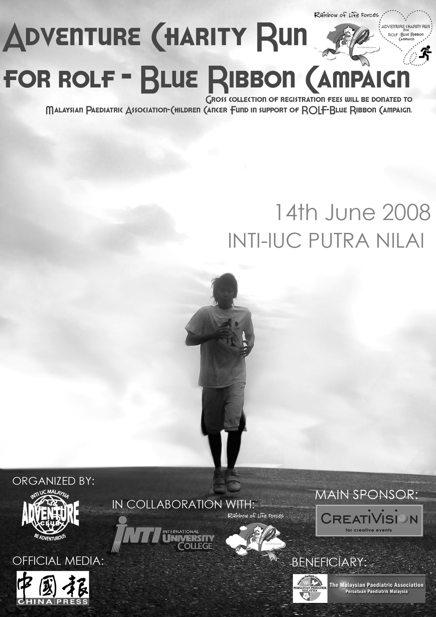 1A

Adventure Charity Run for ROLF - Blue Ribbon Campaign
Entry Form

Date : 14th June 2008 (Saturday)
Time : 06.00AM
Venue : INTI International University College (Nilai Campus)
Entry Fee : RM 18 for (Category A & B), RM15 for (Category C & D),
RM 10 for (Category E & F), RM30 for (Category G)
(Gross collection will be donated to Malaysian Paediatric Association – Children Cancer Fund in support of ROLF – Blue Ribbon Campaign)
Closing Date : 31st May 2008

Full Name (BLOCK LETTERS) (4 names for Category G, include all the participant’s names)
Address (BLOCK LETTERS)

NATIONALITY: TELEPHONE NO:

DATE OF BIRTH:

E-MAIL ADDRESS: SEX: Male/Female

I/C NO. Or PASSPORT:

CODE | CATEGORY | AGE GROUP | STARTING TIME | DISTANCE | ENTRY FEE | TICK (√)
A | Men | 16yrs & above (Born 1992 & Before) | 7.30am | 10km | RM18
B | Women | 16yrs & above (Born 1992 & Before) | 7.30am | 10km | RM18
C | Men | 13yrs & above (Born 1995 & Before) | 7.35am | 5km | RM15
D | Women | 13yrs & above (Born 1995 & Before) | 7.35am | 5km | RM15
E | Men | 40yrs & above (Walk) | 7.40am | 3km | RM10
F | Women | 35yrs & above (Walk) | 7.45am | 3km | RM10
G | 2 Parents & 2 Children | Children must be 12yrs & below (Born 1994 & after) | 7.50am | 3km | RM30
** A rebate of RM5/- will be given to each participant if the group has a total minimum of 30 participants.

WAIVER CLAUSE
This is to certify that I, ______________________________, I/C / Passport No.______________________________
have read and understood the rules and regulations pertaining to my participation in the Adventure Charity Run For ROLF - Blue Ribbon Campaign organized by the INTI International University College 12th INTIMA Adventure Club. In consideration of the acceptance of my entry, I for my heirs, executors & administrator, release and forever discharge the INTI International University College 12th INTIMA Adventure Club, their partners, sponsors, their appointed staff and officials of all liabilities, claims, actions, damage, costs or expenses which I may have against them arising out of any way connected with my participation in this event, including travel to and fro this event and including all injuries that may be suffered by me before, during and after the event. I understand that this indemnity includes any claims based on negligence, action or inaction of any of the above parties. I recognize the difficulties of the event and attest that I am sufficiently physically fit to compete safely in the Adventure Charity Run for ROLF - Blue Ribbon Campaign and I have not been advised otherwise by a qualified medical professional.

Signature of Participant: _______________________ Date: _________________

Signature of guardian (for participants below 18yrs): ___________________________







Organized By: Main Sponsor: In Collaboration With: Official Media: Beneficiary:

1B
Entry Form for School

School Name:
Address:

Teacher in-charge: Total number of participant:
Contact No: Total amount collected:

No. | Name | I/C No. | Category
** A rebate of RM5/- will be given to each participant if the school/institution has a total minimum of 30 participants.

Please note that this form is to be completed by the teacher in charge.
Should the form above is insufficient, please photocopy this form and attach together with the original form.
Each school should only submit ONE Form 1B (with extra if insufficient) attached with Form 1A from all participants.
Please ensure all students who are participating in this run are current students of your school/institution.

Name of Teacher: _______________________

Signature of Teacher-in-charge: ______________________ School Stamp:

Adventure Charity Run for ROLF - Blue Ribbon Campaign
Terms and Conditions:
The age qualification is taken as of 31st December 2007.
1) Entry Forms are available:
• Student Affair Office, INTI International University College.
• Entry forms can also be downloaded from http://www.intimal.edu.my/clubs/adventureclub/
• For further information, email us at inti_adventurerun08@intimal.edu.my
2) Form can be sent by mail, fax, or email.
3) METHOD OF PAYMENT:
I. Kindly bank in money or cheque to CIMB BANK with account number 14160011940058
II. For cheque, Payee : MPA Children’s Cancer Fund
Account No.: 14160011940058
III. Kindly mail or fax the bank-in-slip with :
Attn. Adventure Club (SAO) and indicate Name, I/C Number, Amount Paid, Date of Payment and Contact Number (House/ Mobile)
(Gross collection will be donated to Malaysian Paediatric Association – Children Cancer Fund in support of ROLF – Blue Ribbon Campaign)
MAILING ADDRESS:
Adventure Charity Run for ROLF - Blue Ribbon Campaign
INTI International University College (SAO)
Persiaran Perdana BBN
Putra Nilai 71800 Nilai
Negeri Sembilan, Malaysia.
Fax: +606-7997531
4) SAFETY PRECAUTIONS:
• Participants are only allowed to run/walk on the left hand side of the road except when directed by the officials and the police. Unauthorized
vehicles are NOT allowed to accompany any participants.
5) Closing Date: 31st May 2008.
6) TIME LIMIT: The run will officially be over in 3 hours after the starting time.
7) HEALTH CONDITION: Participants are advised to undergo a check-up 1 month prior to the date of the event.
8) COLLECTION:
1. We will inform you by EMAIL to collect the running tag, T-shirt and a run-card. Please present your receipt upon collection. The time, date
and venue of collection are as follows: -
• 5th – 6th June 2008 from 9am – 5pm at INTI INTERNATIONAL UNIVERSITY COLLEGE. Persiaran Perdana BBN, Putra Nilai,
71800 Nilai, N. Sembilan, Malaysia.
• 7th June 2008 from 9am – 5pm at INTI COLLEGE SUBANG JAYA. 3 Jalan SS 15/8, 47500 Subang Jaya, Selangor, Malaysia.
(Please note that numbers will not be distributed on the day of the race and supply of T-shirts & sizes are subject to availability)
9) CERTIFICATES:
Certificates are awarded as follow: (Categories A, B, C, D)
i. CERTIFICATE OF ACHIEVEMENT:
• Men completing the 5km course in 45min.
• Women completing the 5km course in 60min.
ii. CERTIFICATE OF PARTICIPATION:
• Men completing the 10km course in 90min.
• Women completing the 10km course in 100min.
10) PRIZES
POSITION | A | B | C | D | E | F | G
1 | RM500 | RM500 | RM300 | RM300 | Hamper | Hamper | Hamper
2 | RM300 | RM300 | RM200 | RM200 | Hamper | Hamper | Hamper
3 | RM150 | RM150 | RM100 | RM100 | Hamper | Hamper | Hamper
MEDAL | 50 | 50 | 50 | 50
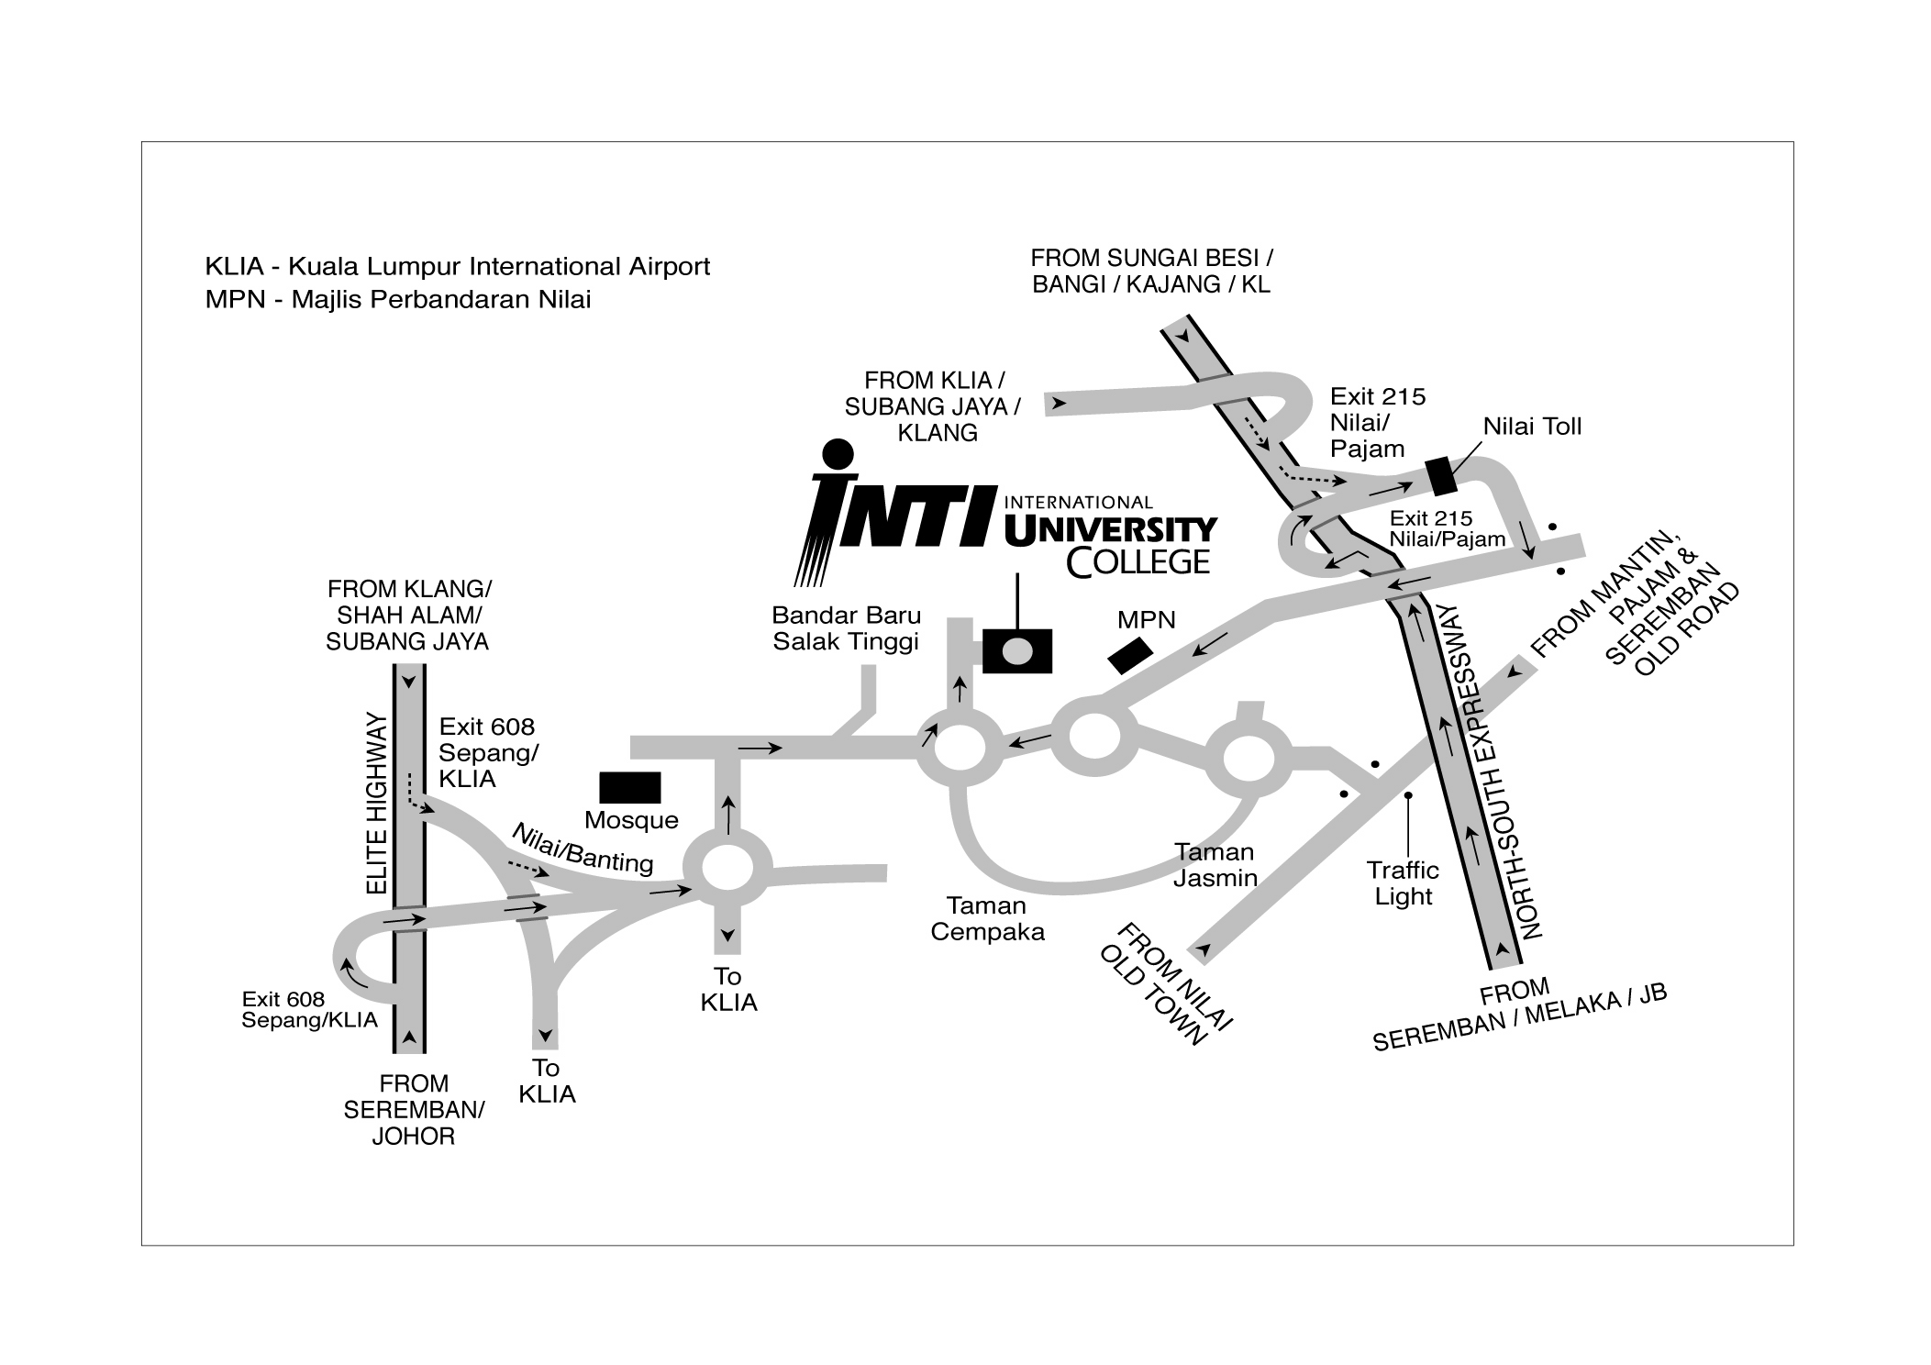
11) All participants are required to produce I.C or passport upon request age, sex and status verification.
12) For additional information, please visit http://www.intimal.edu.my/clubs/adventureclub/ or email your enquiry to
inti_adventurerun08@intimal.edu.my or contact Calvin +60166015480
Direction:

