Results of the Internet-based Workshop on Plasma Focus Numerical Experiments

S Lee
Institute for Plasma Focus Studies, 32 Oakpark Drive, Chadstone, VIC 3148, Australia
NTI International University College, 71800 Nilai, Malaysia
Nanyang Technology University, National Institute of Education, Singapore 637616

e-mail: leesing@optusnet.com.au

Abstract

The Institute of Plasma Focus Studies was founded with the aim of using the Lee model code to assist training of focus scientists in the same way that the UNU ICTP PFF was used successfully to train a generation of plasma focus researchers. The inaugural activity of the IPFS was an internet-based Workshop on Plasma Focus Numerical Experiments. Over 4 weeks, 30 participants were guided to configure the RADPFV5.13.9b to operate a range of machines from the tiny PF400 to the 1 MJ PF1000. Important exercises included fitting a plasma focus so that the computed current waveform agrees, in axial and radial features, with the measured waveform, thus obtaining the model parameters of that particular machine. Computed properties were tabulated side-by-side for a small and a big machine to show similar properties and scalable properties. The evolution of current profiles with pressure was traced for a neutron yielding focus as well as for a neon soft x-ray yielding focus. 18 participants from 9 countries successfully submitted all exercises. A surprising development is also reported. This concerns an additional exercise given to participants to be attempted in future. Numerical experiments in connection with this exercise show that contrary to what Nukulin and Polukhin surmised, there is neither current nor neutron saturation attributable to purely electrodynamic effects for plasma focus machines up to 25 MJ. The numerical experiments show that early peaking of the current profile for megajoule banks invalidates the crux of the N & P argument. The numerical experiments also find the conditions at which a 3 MJ plasma focus may yield 10¹³ D-D neutrons, a landmark target for materials testing in connection with first wall materials in fusion reactors.

1. Introduction
The Institute for Plasma Focus Studies was founded to promote the understanding of plasma focus devices. The method used will be communication through the internet. The main instrument will be the plasma focus simulation package based on the Lee model, the latest being the version RADPFV5.13.9b.
From the mid-Eighties to mid-Nineties and on to the new Millennium a group assisted in the starting and strengthening of several laboratories on plasma focus studies [1] , using a 3 kJ plasma focus the UNU/ICTP PFF, specially designed for that purpose. More than 20 Fellows were trained to build, use and maintain this plasma focus through intensive hands-on training programmes sponsored by UNU, ICTP, UNESCO and TWAS and the AAAPT. This plasma focus, though low-cost, has proved very useful in the

Keynote address International Workshop on Plasma Computation & Applications IWPCA2008, Kuala Lumpur, 14 July 2008

education of plasma focus scientists [2]. It is now actively operated in 7 countries and research on it has produced more than 22 PhD theses, 50 Masters theses and 200 peer reviewed research papers.
From the very beginning of that program it was realized that the laboratory work should be complemented by computer simulation. A 2-phase model was developed in 1984 [3,4]. Over the years we have developed the model until its present form [5-7]. It now includes thermodynamics data so the code can be operated in H₂, D₂, He, Ne, Ar, Xe. We have used it to simulate a wide range of plasma focus devices from the sub-kJ PF400 (Chile) through the small 3kJ UNU/ICTP PFF (Network countries), the NX2 3kJ Hi Rep lithographic focus (Singapore), medium size tens of kJ DPF78 & Poseidon (Germany) to the MJ PF1000 [7]. An Iranian Group has modified the model, calling it the Lee model, to simulate Filippov type plasma focus [8].
We are now confident that the Lee model in its latest coded version the
RADPFV5.13.9b; can realistically simulate all Mather type plasma focus, from small to large, and produce reliable results for all the electrodynamic processes including axial and radial trajectories, total discharge currents and plasma currents, energy distributions; and also giving a good representation of the temperature waveform, radiation yields and neutron yields [7].
Although we can simulate any given machine, without any experimental input, our standard practice requires a measured total discharge current versus time waveform from the specific machine together of course with the bank parameters (capacitance, static inductance), tube parameters (cathode/anode radii, anode length) and operating parameters (voltage, pressure and which gas). We then configure the code with these parameters; and further use 4 model parameters (a mass swept-up factor and a plasma current factor for each of axial and radial phases) to fit the computed total discharge current trace to the experimental total discharge current trace. The process, carried out separately for axial and radial phases, usually ends with an excellent fit for both shape and absolute magnitudes of the total current waveform [9-12].
The total discharge current, particularly the fraction of it flowing in the plasma, drives all the electrodynamic processes in the axial and radial phases; even the plasma heating and radiation are coupled into the equation of motion during the pinch phase.
Conversely all these processes are reflected back in the profile of the plasma current and hence the total discharge current. The total discharge current carries in its profile and magnitudes the information about all the processes that go on in the plasma focus. Thus having fitted the computed I_{total} trace with the measured I_{total} trace, we then have the confidence that all the processes are realistically simulated; and the numerical results are realistic representation of the actual properties of that particular plasma focus.
In the last 3 months of 2007 numerical experiments using the code found a new effect, the plasma focus pinch current limitation effect [11,12]. We also re-formulated neutron yield scaling laws from the numerical experiments [9] and defined a numerical procedure [10] to compute pinch current I_{pinch} from the waveform of the easily measured total discharge current I_{total.}. This code is a universal numerical laboratory that will complement any plasma focus laboratory; acting as a powerful research tool that goes beyond the normal experimental reach. The power of this tool is only limited by the researcher’s limit in imagination.
As an inaugural exercise of the IPFS the Internet-based Workshop on Plasma Focus Numerical Experiments was held from 14 April to 19 May 2008.

2. The Program
The program was divided into 4 parts.
The first part introduced the worksheet, guiding the participant to configure the code as a Numerical Plasma Focus Laboratory (UPFL) to operate as any plasma focus. The input data to configure each focus are: the bank parameters static inductance L₀, capacitance C₀ and circuit resistance r₀; the tube parameters outer radius b, inner radius a and tube length z₀ and operational parameters voltage V₀ and pressure P₀ and the fill gas. The model parameters representing the mass swept-up factor f_{m}, the plasma current factor f_{c} for the axial phase and factors f_{mr} and f_{cr} for the radial phases are also required. As an example the participant operated the NX2 [13,14], studied the results {see Fig 1) and completed an exercise with some measurements taken from the results displayed by the worksheet after a shot. Notes were supplied to emphasize the importance of the inductive and resistive effects of plasma focus dynamics on the current time profile; the fact that all energetic processes are reflected in the current waveform.

Fig 1. The worksheet configured for NX2 Neon, showing the results of a shot.
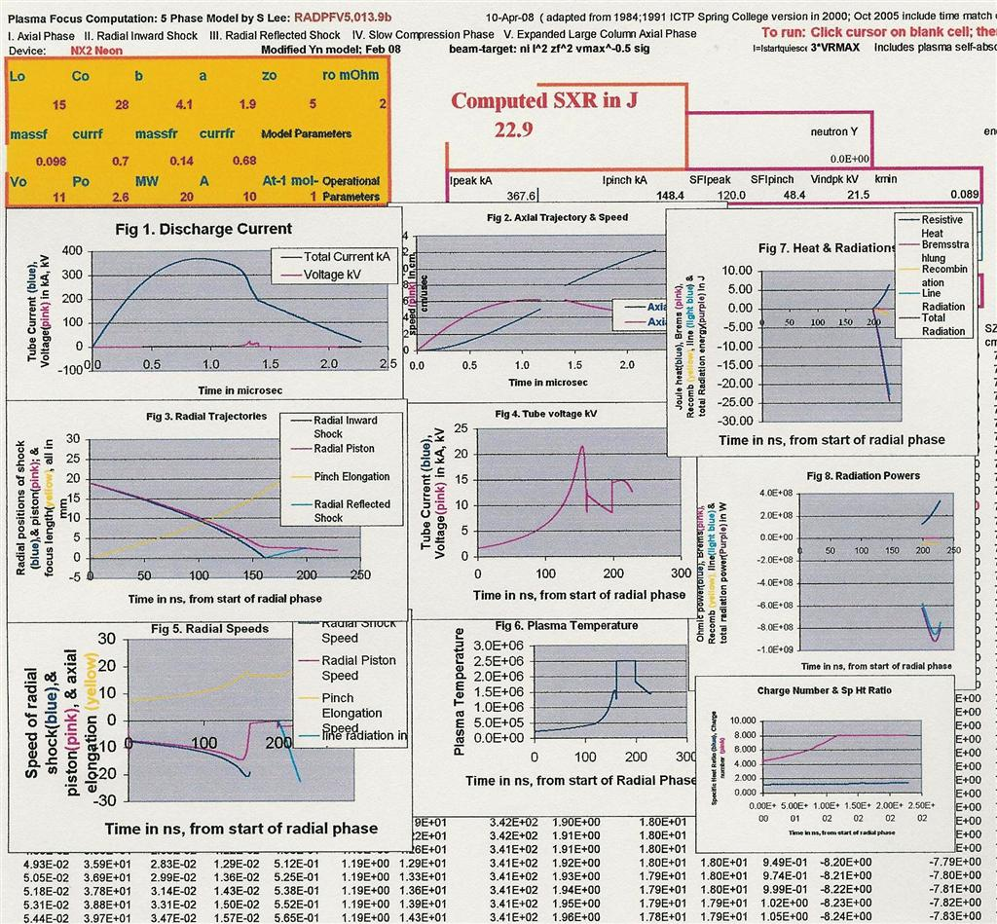

What about the model parameters? In the second part of the program, a participant was guided to configure the code as the biggest plasma focus in the world the 1 MJ PF1000 using guessed trial model parameters, fire the focus, and adjust the trial model parameters progressively until the computed current waveform agreed with a published current waveform of the PF1000 [15].
The axial phase is fitted first, followed by the radial phase (see Fig.2a-c). As an exercise, a participant was then required to fit the PF400 [16], with storage energy several thousand times smaller than the PF1000. A side-by-side tabulation of the results for the BIG and small machines show similar properties, such as speeds, temperature (energy density), ratios of "peak pinch dimension/inner radius", and scalable properties such as pinch dimensions and times and neutron yield (Fig 3). The physics of the similarity and scaling was discussed [5-7,17]. The importance of clearly distinguishing pinch current I_{pinch} from peak total current I_{peak} was emphasized [9-12].

Fig 2a. Computed current trace not agreeing with measured trace; need to adjust f_{m}, f_{c}.
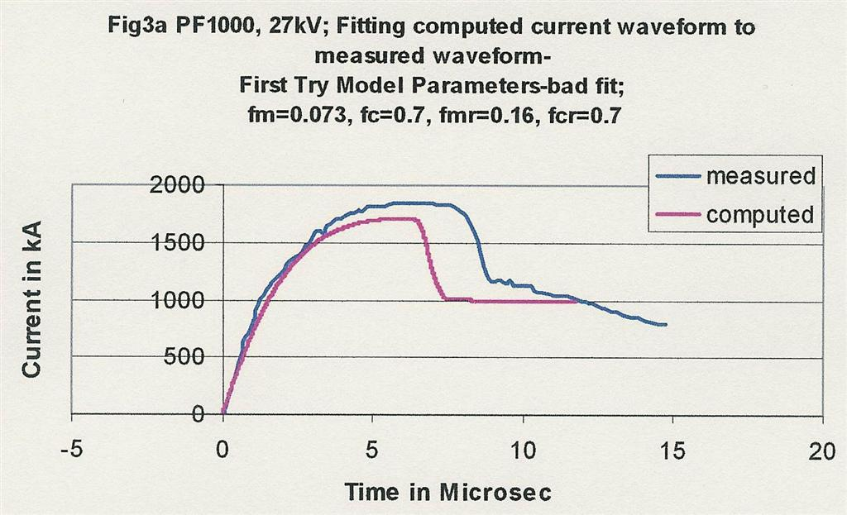
Fig 2b. Computed trace agrees with measured trace, up to end of axial phase.
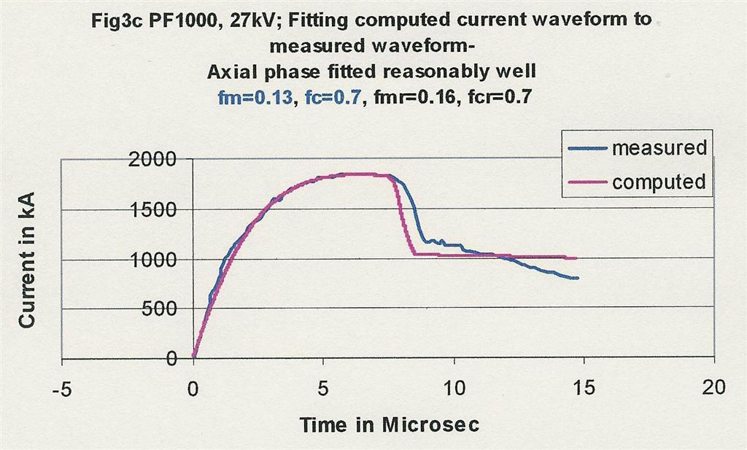
Fig 2c. Computed trace agrees with measured trace; reasonable fit to end of pinch phase.
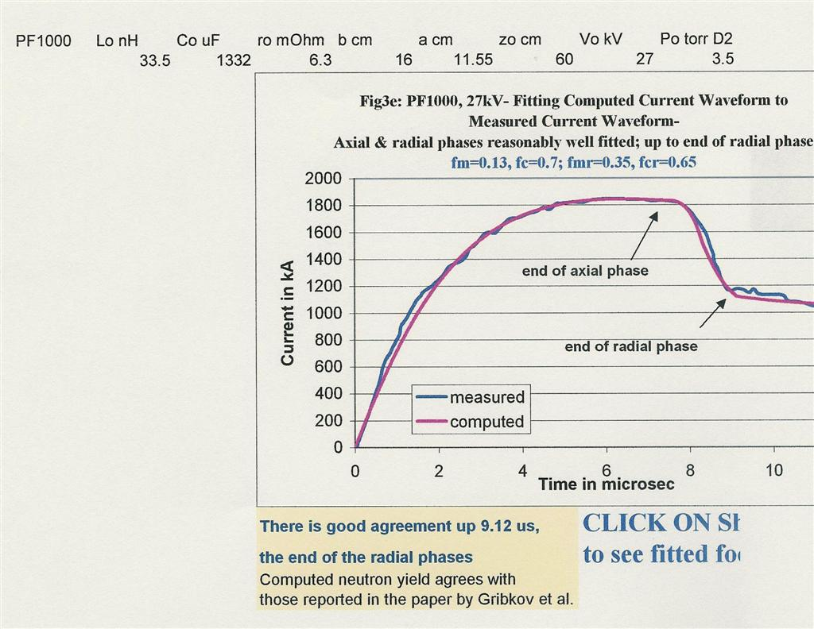

Fig 3. Comparing properties of a BIG & a small focus, showing Similar properties & Scalable Properties.
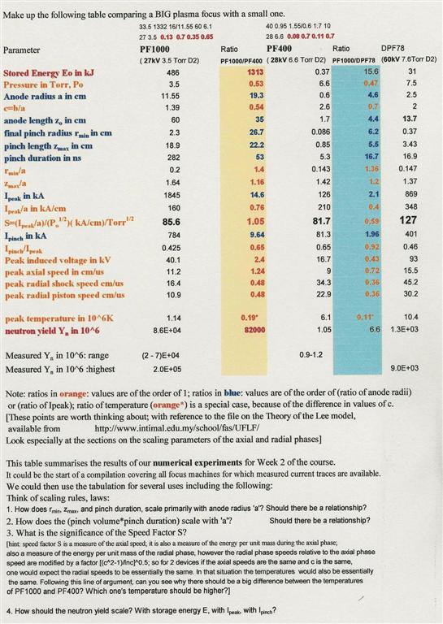

Part 3 went on to guide a participant to more advanced fitting situations; e.g. how to fit the stray circuit resistance r₀ (commonly not given by experimenters), or values of L₀ and C₀ in cases (commonly encountered) where nominal (or inaccurate values) are given. Even given values of z₀ may need to be fitted as 'effective values' as well as a time shift given to the whole measured current trace to account for break-down times and switching processes. An exercise was given to a participant to fit the DPF78 [10], which required some of these more advanced fitting considerations.
Part 4 took the participant back to work on the PF1000; operating the PF1000 from short-circuit- like high pressure, through to optimum pressure for neutron yield, and then down to lower pressures (Fig 4). In the process the neutron yield was plotted as a function of pressure. Various other properties were also plotted for the participant to get a feel of any correlations (see Fig 5). For example as the pressure was increased, I_{peak} was seen to increase continually with pressure whereas I_{pinch} reached a maximum value at a pressure close to the optimum pressure for neutron yield. This emphasized again the importance to distinguish clearly I_{peak} and I_{pinch} in the analysis of plasma focus performance.

Fig 4. Showing evolution of current trace with pressure; the greater and greater distortion of the current traces (from sinusoid) is due to greater dynamic resistance with greater speeds as pressure is reduced.
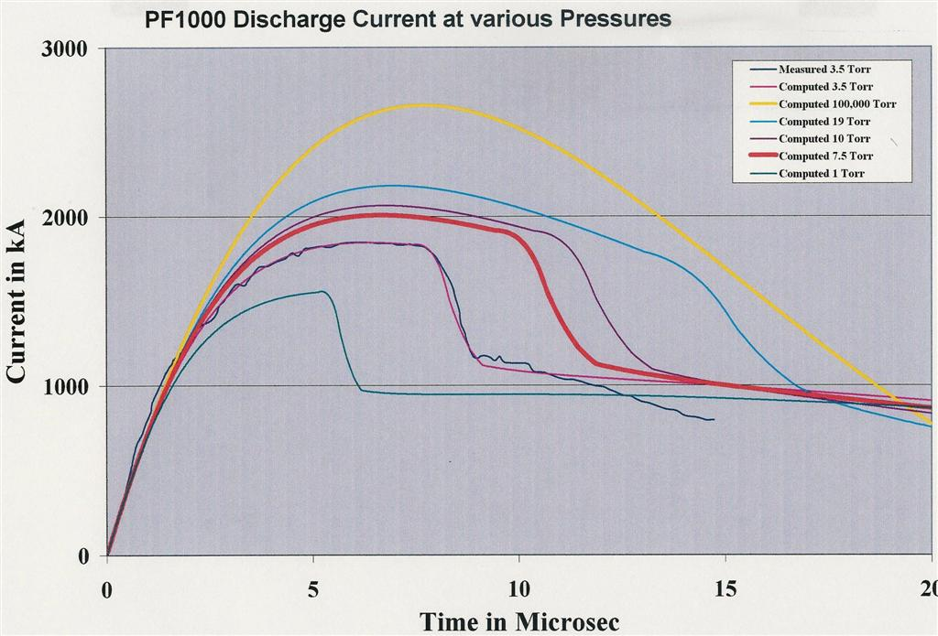

The second section of Part 4 had the participant working on the NX2 neon soft x-ray production as a function of pressure (Fig 6), again plotting the yield and various focus pinch properties against pressure (Fig 7) to enhance the understanding of correlation. Moreover the soft x-ray yield versus pressure curve was found to agree with experimental measurements.

Fig 5. Variation of Yn, speeds, pinch dimensions & other properties with pressure.
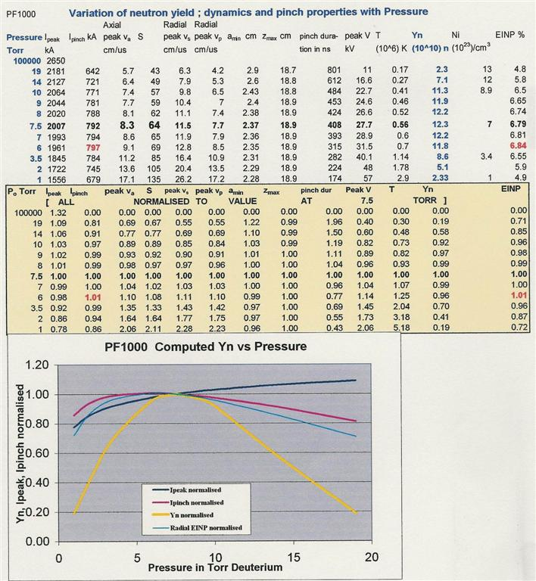

Fig 6. Evolution of discharge current in NX2 as a function of pressure.
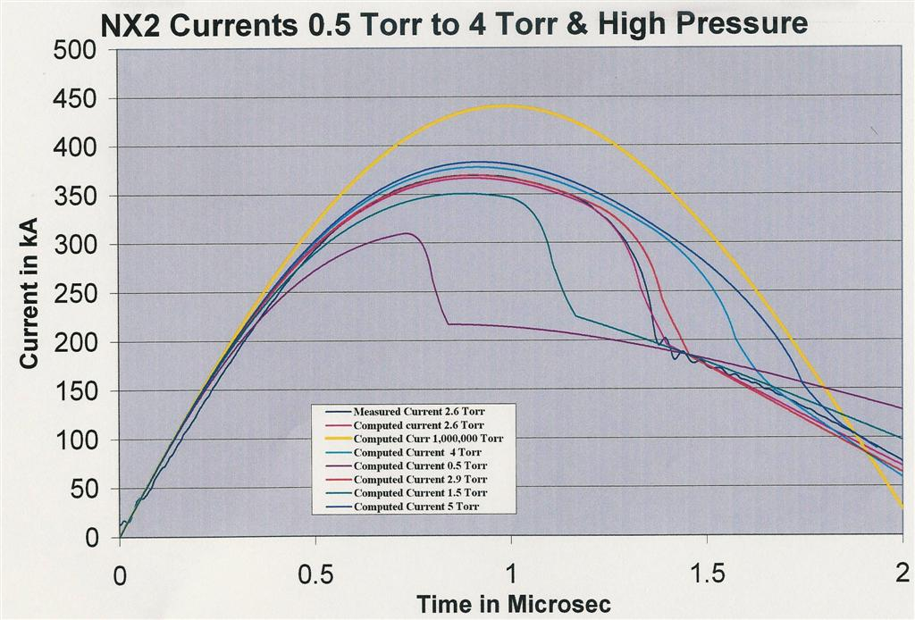

Fig 7. Variation of Y_{sxr}, speeds and pinch properties with pressure of NX2, Hi Rep Focus developed for microelectronics lithographic & micromachining purposes. The attached graph also shows comparison of computed yield curve vs measured yield points.
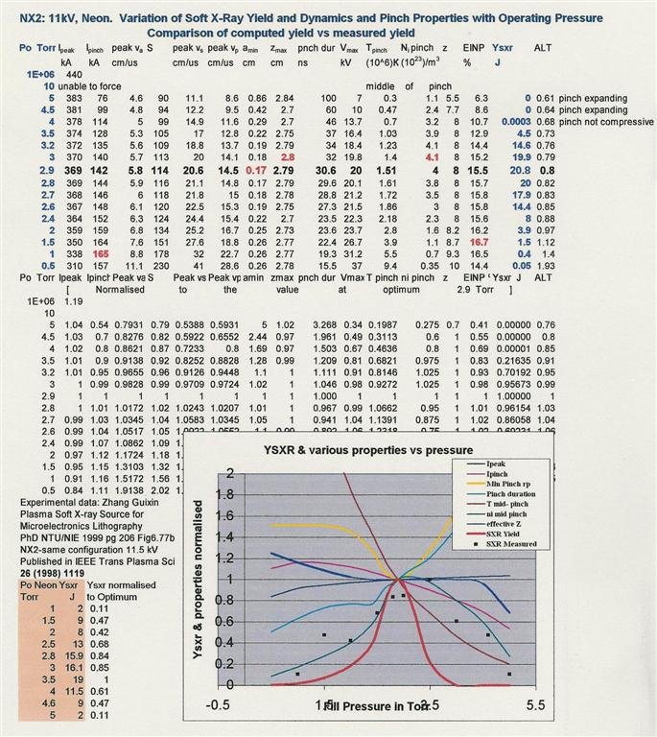

3. Participation
Eighteen participants submitted all exercises. There was a lively exchange of views, in the discussion of the physics of the plasma focus. Regarding the fitting of the model parameters in some cases, particularly for the PF1000, there appeared to be some difference of opinion as to what constituted the best fit. There emerged the consensus that one is not able to get a perfect fit; in the sense that you can defend it as absolutely the perfect fit. The way to treat it is that one has got a working fit; something to work with; which gives comparable results with experiments; rather than perfect agreement. There is no such thing anyway; experiments on any one plasma focus under consistent conditions give a range of results; especially in yields (factor of 2-5 range is common). Thus several slightly differing working fits should still all give results that fall within the range of the hardware experiment.
Even though a fit may only be a 'working' fit (as opposed to the hypothetical perfect fit) when one runs a series of well planned numerical experiments one can then see a trend e.g. how properties, including yields, change with pressure or how yields scale with I_{pinch}, or with L₀ etc. And if carefully carried out, the numerical experiments can provide, much more easily, results just like hardware experiments; with the advantage that after proper reference to existing experiments, then very quickly one can extend to future experiments and predict probable results.

4. Additional exercises
In order to engage the participant beyond the workshop to emphasize that the UPLF is to be used as a tool in later work two additional experiments were proposed. The first involved a simple exercise to run the code for PF400 neutron yield [16] as a function of pressure and to compare the computed results with published results of the PF400. The second outlined the broad idea of using the code to verify (or not) the Nukulin and Polukhin (N & P) idea that for megajoule plasma focus machines current and neutron yield saturate from a consideration of purely electrodynamic effects [18].

5. Results arising out of the additional exercises
In order to be able to answer prospective queries from participants in future, numerical experiments were then carried out. For the PF400, the numerical experiments resulted in a paper to be presented in this Workshop. Although a simple exercise, the results establish the state of the art, since before this effort, all plasma focus neutron computation only compared with the measured values in order of magnitude.
Numerical experiments carried out to verify the N & P idea for the second additional exercise very quickly showed that the crux of their argument is wrong; in fact based on purely electrodynamic consideration, there is no saturation for I_{peak}, I_{pinch} or Y_{n}. A detailed study followed, which revealed that their error was related to assumptions of current profile. Numerical experiments show that there is a very early peaking (Fig 8) of the current profile for megajoule devices, whereas the N & P scenario envisaged a much longer current risetime of the order of (L_{a}C₀)^{0.5} where the inductance of the coaxial tube L_{a} is further assumed in the N & P scenario to be proportional to C₀.

Fig. 8. Comparing the N & P scenario waveform and the computed waveform.
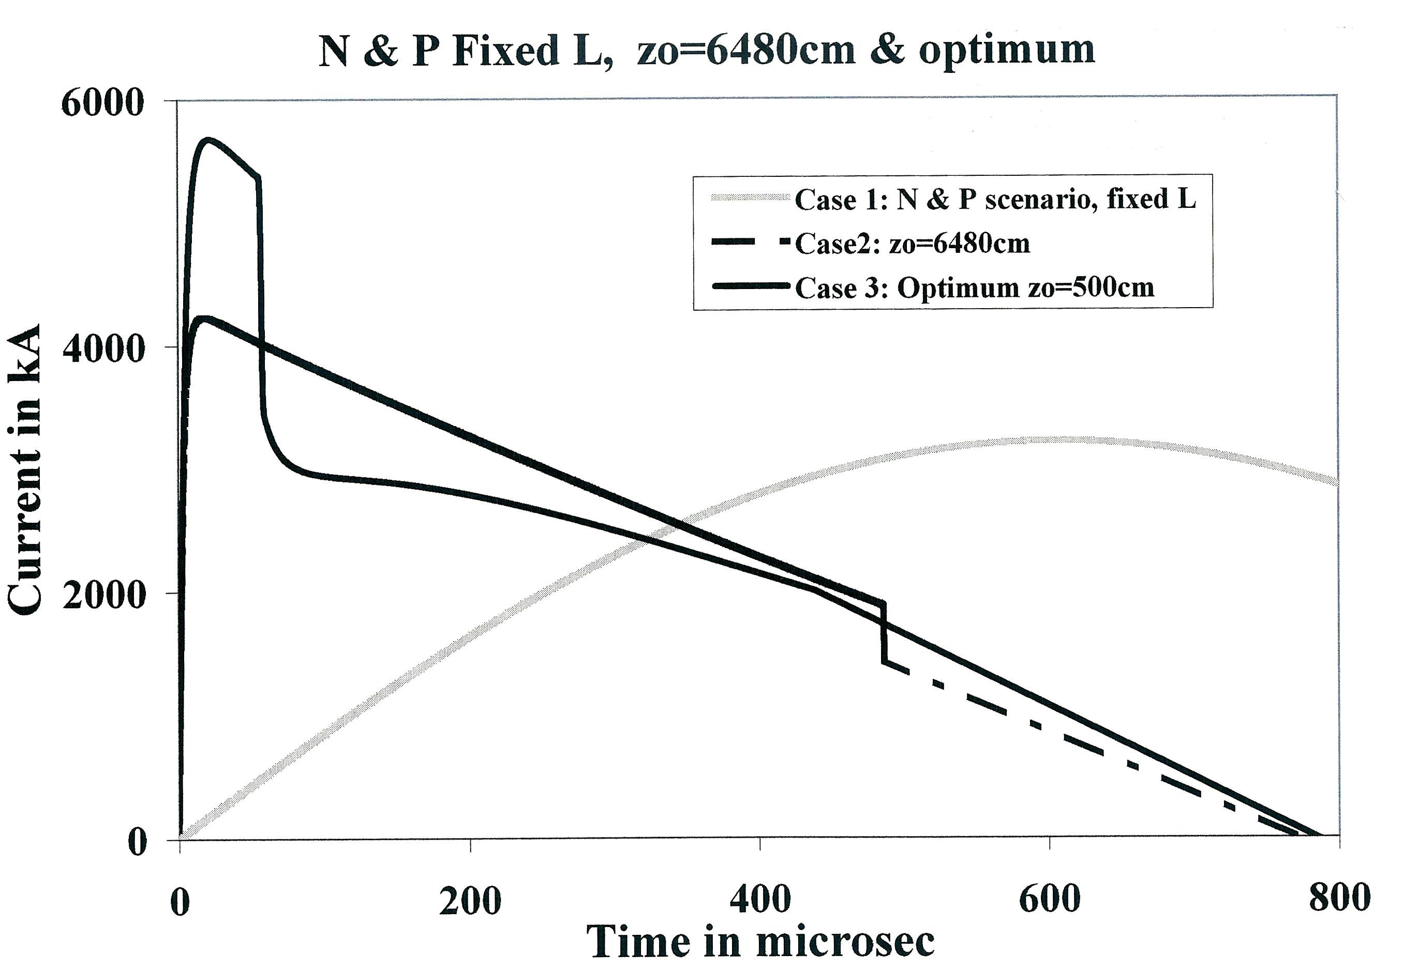

Fig 9. Computed currents showing no saturation, as opposed to the N & P scenario.
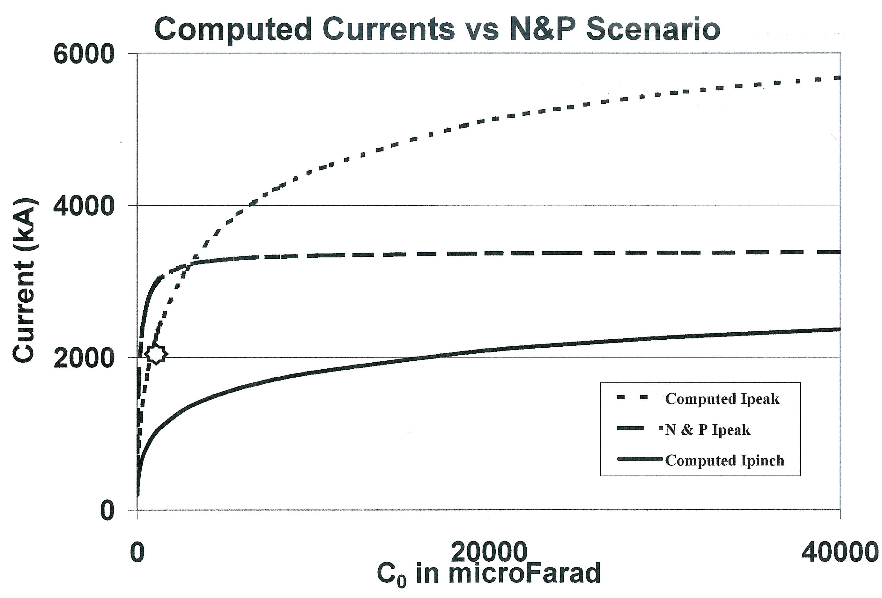
The numerical studies gave the following important results [19]:
Y_{n}~E₀² for low (kJ) energies; this scaling slows down to Y_{n}~E₀^{0.84} for megajoule energies up to the 25 MJ levels investigated.
The scaling of Y_{n} with I_{peak} and I_{pinch} shows similar slowing down at high megajoules.
As a result, over the whole range of energies from kJ up to the 25 MJ level investigated, it was found that the scaling of Y_{n} with currents are as follows:

Y_{n}~I_{peak}^{3.8} and
Y_{n}~I_{pinch}^{4.5}

This is the first time that neutron scaling with I_{peak} or I_{pinch} up to such high energies has been formulated. The currents involved go up to 6.7 MA for I_{peak} and 2.7 MA for I_{pinch}.
Furthermore, numerical experiments found the conditions to reach the landmark target of 10¹³ D-D neutrons per shot (convertible to 10¹⁵ D-T neutron), for cost-effective testing of materials for first wall

components in magnetic & inertial confinement fusion reactors [20] as follows:

PF1000-like banks at 35 kV: 18 MJ
Modern, low-damped banks: 8 MJ
High voltage (90 kV) banks: 3 MJ at I_{pinch} of 2.5 MA

6. Conclusion
A report of the Internet-based Workshop on Plasma Focus Numerical Experiments is given. The Lee model code is used as a Universal Plasma Focus Laboratory Facility, configured to operate as a range of plasma focus from very small to very big for neutron yield and soft x-ray yield. Major points emphasized in the activity include model fitting, similar and scalable properties of the plasma focus, evolution of current waveforms, neutron and soft x-ray yields, and focus properties with pressure, and the importance of distinguishing between I_{pinch} and I_{peak} for scaling purposes. Arising from additional exercises, important results pertaining to current and neutron scaling of megajoule plasma focus machines were obtained, and prepared for publication [19].

References

[1] Sing Lee & Chiow San Wong. Physics Today. May 2005 31-36
[2] Lee S 1998 Twelve Years of UNU/ICTP PFF—A Review IC, 98 (231) Abdus Salam ICTP, Miramare, Trieste; ICTP OAA: http://eprints.ictp.it/31/
[3] Lee S 1984 Radiations in Plasmas ed B McNamara (Singapore: World Scientific) pp 978–87 1S.
[4] Lee S in Laser and Plasma Technology, edited by S. Lee, B. C. Tan, C. S.
Wong, and A. C. Chew. World Scientific, Singapore, 1985_, pp. 387–420.
[5] Lee S 2000/2007 http://ckplee.myplace.nie.edu.sg/plasmaphysics/
[6] Lee S 2005 ICTP Open Access Archive: http://eprints.ictp.it/85/
[7] Lee S Radiative Dense Plasma Focus Computation Package: RADPF http://www.intimal.edu.my/school/fas/UFLF/
[8] Siahpoush V, Tafreshi M A, Sobhanian S and Khorram S 2005 Plasma Phys. Control. Fusion 47 1065
[9] Lee S and Saw S H Neutron scaling laws from numerical experiments J. Fusion Energy at press
[10] Lee S, Saw S H, Lee P C K, Rawat R S and Schmidt H 2008 Appl. Phys. Lett. 92 111501
[11] S Lee, P Lee, S H Saw and R S Rawat. Plasma Phys. Control. Fusion 50 (2008) 065012
[12] Lee S and Saw S H 2008 Appl. Phys. Lett. 92 021503
[13] Lee S, Lee P, Zhang G, Feng X, Gribkov V A, Liu M, Serban A and Wong T 1998 IEEE Trans. Plasma Sci. 26 1119
[14] Bing S 2000 Plasma dynamics and x-ray emission of the plasma focus PhD Thesis NIE ICTP Open Access Archive: http://eprints.ictp.it/99/
[15] Gribkov V A et al 2007 J. Phys. D: Appl. Phys. 40 3592
[16] Patricio Silva, Jose Moreno, Leopoldo Soto, Lipo Birstein, Roberto E. Mayer
and Walter Kies 2003. Appl. Phys. Lett. 83, 3269
[17] Lee S and Serban A 1996 IEEE Trans. Plasma Sci. 24 1101–5
[18] Nukulin V Ya and Polukhin S N 2007 Plasma Phys. Rep. 33 271–7
[19] S Lee. Current and Neutron Scaling for Megajoule Plasma Focus Machines, submitted to Plasma Phys & Controlled Fusion, June 2008
[20] Gribkov V A et al 2007 J. Phys. D: Appl. Phys. 40 1977

